Language and Its Use
Consciously
Using racist language-  Not concerned or  Deliberately malicious |  | Always aware of the  effect of language-  Careful use of words
Insensitive |  |  | Sensitive
Occasionally using language  that is racist –  Unaware of the implications |  | Could be more careful  with use of words-  Few adverse consequences
Unconsciously
Adapted from the Equal Opportunities Handbook by Phil Clements & Tony Spinks

Language: Principles and Considerations

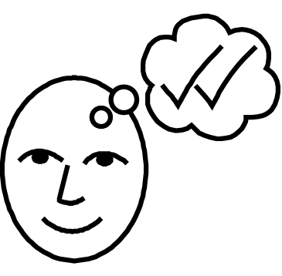Principles & Considerations
- Appropriateness/relevancy
- Sensitivity
- Intention
- Impact

Racist attitudes & behaviour can be heard in:

What people say
How people say it
Type of language
Throw-away comments
Jokes
Asides (words spoken so that only certain people will hear)

The Equal Opportunities Handbook by Phil Clements & Tony Spinks

